Analysis of Revenue and Profitability in the Bus Transport Sector in India

Project Overview
This project aims to analyze the financial performance of the Indian bus transport sector, focusing on revenue and profitability drivers for both public (State Transport Undertakings or STUs) and private operators. The overview includes an assessment of key performance indicators like fleet utilization, vehicle productivity, and operational costs against revenue streams, with the ultimate goal of identifying challenges and recommending strategies for improvement, such as enhancing operational efficiency to boost profitability.

Project Objectives
- Assess the current financial health and performance trends of public and private bus operators.
- Identify key factors influencing revenue, such as ticket pricing, route density, and passenger occupancy.
- Analyze major cost components, including fuel, maintenance, and labor, to understand their impact on profitability.
- Evaluate the efficiency of operational metrics like fleet utilization and vehicle productivity and their link to financial outcomes.
- Benchmark performance across different operator types and geographic regions to identify best practices and areas for improvement.
- Propose strategic recommendations for enhancing profitability and financial sustainability.

Data Sources:
  - Source Description and Timeline : Earning from Buses(2015-19)
  - Domain : Open City Urban Data

Problem Statement:

Despite the bus transport sector being a lifeline for 80-90% of commuters and accounting for about 87% of passenger traffic in India, a majority of the operators suffer from substantial financial losses, leading to an unsustainable service delivery model.

This study aims to address the core issue that existing revenue streams and operational models are insufficient to ensure the long-term financial viability and sustainable performance of bus transport services.

Politically influenced fare structures: Fares are often kept artificially low for social welfare, leading to low fare box recovery ratios (often below 70%), which do not cover operational costs.
- High and rising operational costs: Fuel and manpower constitute a major portion of expenses, which continuously increase due to market fluctuations and wage revisions, while revenue growth lags behind.
- Operational inefficiencies: Issues like aging fleets (over 30% of STU buses are over aged), low vehicle utilization, poor route management, and high staff-to-bus ratios result in increased maintenance costs and reduced service reliability.
- Intense competition from unorganized private operators: Illicit private operators often run on profitable routes without paying proper taxes or adhering to regulatory standards, eroding the legitimate revenue base of public operators.
Attribute Details:

 | Attribute Name | Data Type | Description
 | ID | Integer | A unique identifier for each record or data point.
 | CITY | Text | The name of the city the data pertains to.
 | Year | Whole Number | The year the data was collected..
 | Average No. of daily trips | Whole Number | The total number of trips made in a day, averaged over the measurement period.
 | Average No. of passengers | Whole Number | The average number of passengers per trip on a day-to-day basis.
 | Average trip length in km | Whole Number | The average distance, in kilometers, for a single trip.
 | Average cost per km | Whole Number | The average operating cost for every kilometer traveled.
 | Revenue per km | Decimal Number | The average revenue generated for every kilometer traveled.

Tools and Technologies:

Microsoft Excel:
Used Excel ETL Tool Power Query for initial data collection, cleaning, and transformation. Performed data consolidation, removal of duplicates, and preparation of consistent formats before importing into Power BI.

Microsoft Power BI:
The primary tool for data modelling, analysis, and dashboard creation. DAX (Data Analysis Expressions) was used to build custom measures and KPIs, while Power Query Editor handled data transformation and integration.

Data Preprocessing (Excel/Preprocessing)

Data Collection:
Collected Earning from Buses(2015-19) from the Open city Urban data , where yearly data was stored in separate Excel sheets.

Data Consolidation:
Combined all yearly Excel sheets (2015-19) into a single Excel workbook and removed subtotal and description rows for consistency.

Automation Using Macros:
Used Excel Macros Recording to automate repetitive formatting tasks such as column alignment, text formatting, and style standardization across all sheets.

Data Cleaning in Power Query:
Imported the datasets into Power Query Editor in Power BI to perform cleaning operations — filled empty cells using the Fill Down feature, standardized text formats, and ensured uniform data types.

Data Transformation:
Added a calculated flag column for better classification and applied consistent formulas and field names to align both datasets ( 2015–2019).

Data Integration:
Appended the cleaned and formatted datasets from both time periods to create a unified dataset covering 2015–2029, ready for visualization and analysis.

Data Modelling and DAX (Power BI)
Data Modelling: In data modelling
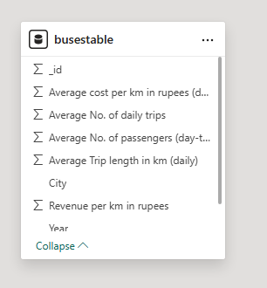

Calculated Columns and DAX Measures:
Using DAX (Data Analysis Expressions), several calculated columns, measures, and parameters were created to enhance analytical insights.
DAX Components Created:

Calculated Columns:
    - Profit status of cost
    - Profit of Revenue per km

Measures:
    - Total Cost, passenger, daily trip, trip length, Revenue
    - Average of Cost, Passenger, Daily trip, Trip Length, Revenue
    - Year base Dax Measures(2015-19)
    - Distinct count of city
    - Revenue per km

Analysis and Visualizations (PowerBI)
To address the identified problem statements, a series of interactive Power BI visualizations were developed. Various charts such as bar charts, line graphs, donut charts, tree maps, and KPI cards were used to analyse mutual fund performance across scheme types and categories, highlighting top-performing funds.
- To analyse cost performance across different scheme types and categories, bar charts were used to identify the top-performing funds and compare performance across scheme categories.
- To evaluate fund mobilization, redemption, and asset management data, custom-made parameters, table visuals, and KPI metrics were developed to assess market growth, total inflows, redemptions, and AUM stability.
- To compare the performance of breakdown revenue over year waterfall charts were utilized to represent and analyse differences in year revenue increase and decrease.
- To identify which scheme categories attract the most Average over years, a combination of slicers, bar graphs, funnel charts, and tree maps was used to provide interactive category-wise analysis.
- To examine monthly and yearly AUM trends for forecasting a stacked area chart was implemented to highlight high revenue and cost and trends over time.
- To analyze the relationship between the number of total passenger by year, a donut chart was used to represent passenger total count over year to overall asset distribution.

Financial performance Analysis
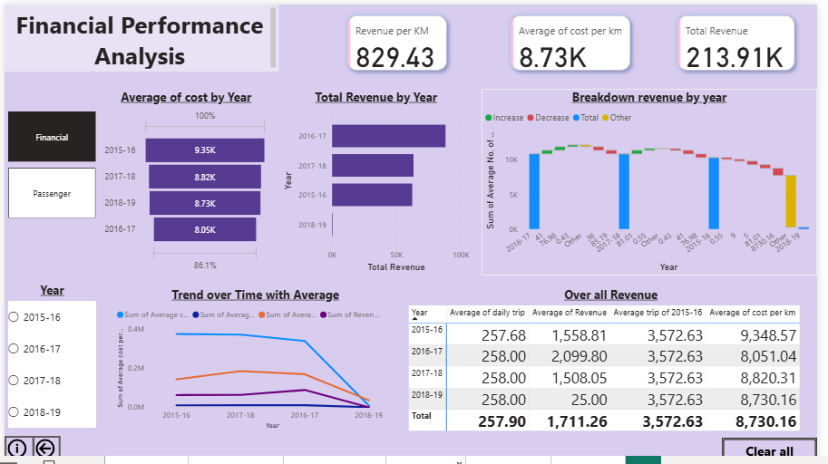

Passenger and Demographic Analysis
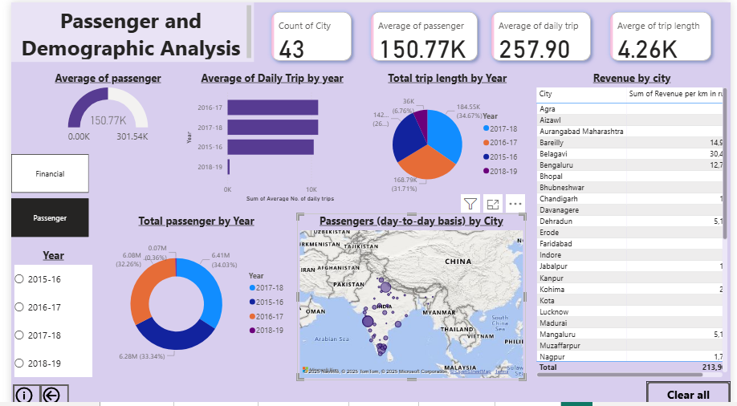

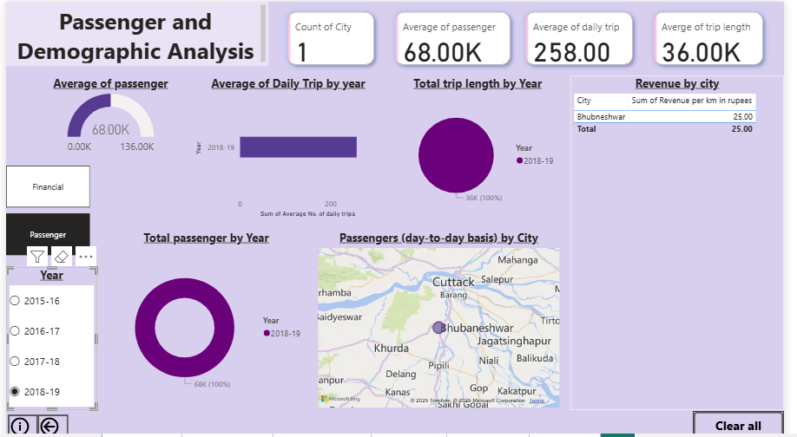

Insights of Financial Performance Analysis
  - At 373,942.89, 2015-16 had the highest Sum of Average cost per km in rupees (daily) and was 4,183.35% higher than 2018-19, which had the lowest Sum of Average cost per km in rupees (daily) at 8,730.16.
  - Sum of Average cost per km in rupees (daily) and total Sum of Average No. of daily trips are positively correlated with each other.
  - 2015-16 accounted for 34.27% of Sum of Average cost per km in rupees (daily).
  - Across all 4 Year, Sum of Average cost per km in rupees (daily) ranged from 8,730.16 to 373,942.89, Sum of Average No. of daily trips ranged from 258 to 10836, and Sum of Average Trip length in km (daily) ranged from 36000 to 184,554.05.
  - 2016-17 had the highest Total Revenue at 88,191.67, followed by 2017-18, 2015-16, and 2018-19.

Insights of Passenger and Demographic Analysis
  - 2016-17 and 2017-18 tied for highest Sum of Average No. of daily trips at 10836.
  - Across all 4 Year, Sum of Average No. of daily trips ranged from 258 to 10836.

Conclusion
The integration of Excel and Power BI enabled a complete analysis of the Earning from Buses from 2015 to 2019, overall trends in the transportation sector can be identified. You can see if trip frequency, length, and passenger numbers are increasing or decreasing over time, and how these factors relate to cost and revenue per km. For instance, increased daily trips might correlate with higher revenue but also potentially higher operating costs.

